Paul Collado
CSC-208-60
Nov 03, 2010

ColladoCh07Page318

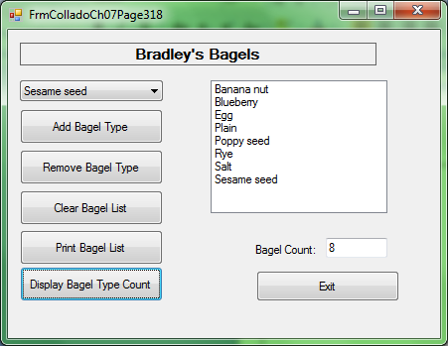

Public Class FrmColladoCh07Page318

Private Sub BtnAdd_Click(ByVal sender As System.Object, ByVal e As System.EventArgs) Handles BtnAdd.Click
If Me.CboBagel.Text <> "" Then
Dim itemFound As Boolean
Dim itemIndex As Integer

Do Until itemFound Or itemIndex = LstOutput.Items.Count
If CboBagel.Text = LstOutput.Items(itemIndex).ToString() Then
itemFound = True
Exit Do
Else
itemIndex += 1
End If
Loop
If itemFound Then
MessageBox.Show("Duplicate item.", "Add Failed", _
MessageBoxButtons.OK, MessageBoxIcon.Exclamation)
Else
LstOutput.Items.Add(CboBagel.Text)
CboBagel.Text = ""
End If
Else
MessageBox.Show("Enter a bagel type to add", _
"Missing Data", MessageBoxButtons.OK, _
MessageBoxIcon.Exclamation)
End If

End Sub

Private Sub BtnRemove_Click(ByVal sender As System.Object, ByVal e As System.EventArgs) Handles BtnRemove.Click
If CboBagel.Text = "" Then
MessageBox.Show("Please select a Bagel type!", "Item Not Selected")
Else
LstOutput.Items.Remove(CboBagel.Text)
End If

End Sub

Private Sub BtnClear_Click(ByVal sender As System.Object, ByVal e As System.EventArgs) Handles BtnClear.Click
Dim button As System.Windows.Forms.DialogResult
button = MessageBox.Show("Clear the Bagel List?", "Clear List", _
MessageBoxButtons.YesNo, MessageBoxIcon.Question)
If button = System.Windows.Forms.DialogResult.Yes Then
Me.LstOutput.Items.Clear()
End If
End Sub

Private Sub BtnDisplayCount_Click(ByVal sender As System.Object, ByVal e As System.EventArgs) Handles BtnDisplayCount.Click
TxtCount.Text = LstOutput.Items.Count

End Sub

Private Sub BtnPrint_Click(ByVal sender As System.Object, ByVal e As System.EventArgs) Handles BtnPrint.Click
PdPrintList.Print()
End Sub

Private Sub PdPrintList_PrintPage(ByVal sender As System.Object, ByVal e As System.Drawing.Printing.PrintPageEventArgs) Handles PdPrintList.PrintPage
Dim PrintFont As New Font("Arial", 20, FontStyle.Italic)
Dim HorizontalPrintLocation As Single = e.MarginBounds.Left
Dim VerticalPrintLocation As Single = e.MarginBounds.Top
Dim LineHeigth As Single = PrintFont.GetHeight
Dim PrintLine As String

For index = 0 To LstOutput.Items.Count - 1
PrintLine = LstOutput.Items(index).ToString()
e.Graphics.DrawString(PrintLine, PrintFont, Brushes.Black, HorizontalPrintLocation, VerticalPrintLocation)
VerticalPrintLocation += LineHeigth
Next index

End Sub
End Class

